Traffic Sign Recognition System using CNN

- Background/ Problem Statement

Traffic sign detection and recognition have gained importance with advances in image processing due to the benefits that such a system may provide. The recent developments and interest in self-driving cars have also increased the interest in this field.
Automatic detection and recognition of traffic signs is very important and could potentially be used for driver assistance to reduce accidents and eventually in driverless automobiles. There are many sign boards on roads that people are unaware of. They might have seen traffic or road signs all the time but don’t understand what those signs are indicating.
Our Traffic Sign Recognition System detects and recognizes road signs or traffic signs from an image and video. It will also recognize signs in real-time using CNN. Here, Deep Convolutional Neural Network (CNN) is used to develop Autonomous Traffic or Road Sign detection.

- Working of the Project

In this system, the user can upload an image for the system to detect and recognize traffic signs. The system can recognize uploaded videos. For real-time traffic sign recognition, the user will need to turn on their device camera and click on the camera button to start detecting.
The system will display the names of the recognized traffic signs. It will also display the probability of the predicted result being accurate. The front-end involves Html, CSS, and JavaScript and the back-end involves Python. The framework used is Django and the database is MySQL.
Here, we have implemented the Convolutional Neural Networks (CNN) model. The Traffic Sign dataset is extracted from Kaggle. We can implement this system on a vehicle from a broader perspective and modify the vehicle by this system to behave as a sign detector in real-time.

- Advantages

- It is easy to maintain.
- It is user-friendly.
- The system automatically detects traffic signs.
- It can recognize signs from an image and videos.
- It can also detect and recognize in real-time.

- System Description

The system comprises 1 major module with their sub-modules as follows:
- USER:
- Detection
  - Image
- The user will need to upload an image for detection.
  - Video
- For detecting signs from video, the user will need to upload an image.
  - Real-time
- To detect in real-time, webcam will be opened and detect.

- Project Life Cycle

The waterfall model is a classical model used in the system development life cycle to create a system with a linear and sequential approach. It is termed a waterfall because the model develops systematically from one phase to another in a downward fashion. The waterfall approach does not define the process to go back to the previous phase to handle changes in requirements. The waterfall approach is the earliest approach that was used for software development.

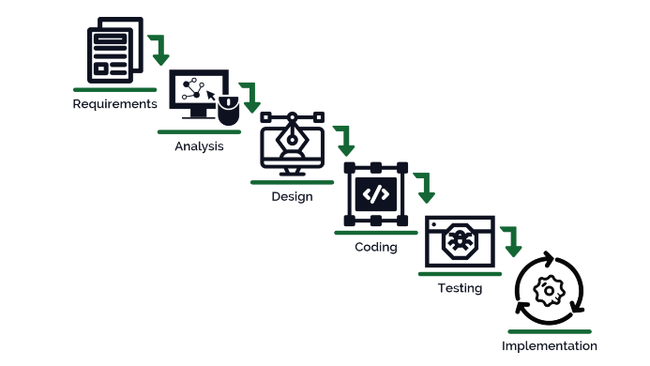

- System Requirements

- Hardware Requirement

- Laptop or PC
- Windows 7 or higher
- I3 processor system or higher
- 4 GB RAM or higher
- 100 GB ROM or higher

- Software Requirement

- Laptop or PC
- Python
- Sublime Text Editor
- XAMP Server

- Limitation/Disadvantages
- The uploaded image or video must contain traffic or road signs.
- The system will detect signs in real-time only if the device camera is on.
- The system won’t run simultaneously in the background.

- Application – This application will detect and recognize traffic signs from images, video and also in real-time.

- Reference
- https://ieeexplore.ieee.org/document/9327830
- https://www.irjet.net/archives/V7/i5/IRJET-V7I5314.pdf
- https://www.ijert.org/traffic-sign-detection-and-recognition-using-image-processing

